INVITATION TO BID - ITB/ICMP/HQ/010726 –
FOR THE SUPPLY OF REFERENCE SAMPLE COLLECTION KITS

- The International Commission on Missing Persons (“ICMP”) is an intergovernmental organization with its Headquarters located at Koninginnegracht 12, 2514AA, The Hague, the Kingdom of the Netherlands. ICMP endeavors to secure the cooperation of governments and other authorities in locating persons missing as a result of armed conflicts, human rights abuses, natural and man-made disasters, and other involuntary reasons and assists them in doing so. More about ICMP and its mandate can be found on ICMP’s website: www.icmp.int.

- ICMP invites true and compliant bids in response to the instructions and specifications indicated below.

- INSTRUCTIONS TO BIDDERS

- Any bid submitted in response to this Invitation to Bid (“ITB") shall constitute an offer by the bidder (“Offer”). The issuance of this ITB and the receipt of any Offer shall not constitute or imply the acceptance of any Offer by ICMP. ICMP reserves the right, in its sole discretion, not to award a contract to any bidder pursuant to this ITB;
- ICMP reserves the right, at its sole discretion and at any time prior to the award of a contract, to amend, suspend, or withdraw this ITB, in whole or in part, without incurring any liability or obligation to any bidder;
- The offering, giving, or promising any inducement of any kind, or the or failure to disclose any actual or potential conflict of interest in connection with this ITB, shall result in the disqualification of the Offer from further consideration;
- All costs incurred for the preparation and submission of Offers are to be borne by the bidders and will not be reimbursed by ICMP;
- All Offers must be in the English language and submitted by email. Offers can be submitted in PDF format via a single email not exceeding 20 MB in size to tender@icmp.int with the email subject “ITB/ICMP/HQ/010726”, by 15:00 CET on 1 August 2026. Offers received after this time and date will be rejected;
- All Offers submitted shall be valid until 31 December 2026 and during which the bidder may not modify the terms of the Offer in any respect;
- The submission of an Offer in response to this ITB implies the bidder’s acceptance of all terms and conditions stipulated herein. These terms and conditions will be binding on the successful bidder for the duration of the potentially awarded contract. Bidders are also required to confirm acceptance of ICMP’s General Terms and Conditions ICMP.CS.96.5.doc (“GTC”) attached as Annex I, subject to any reasonable requests for deviation;
- During the bidding period ICMP may provide additional information solely for the purpose of clarifying the ITB documents. Such information will be published as an addendum to the ITB using the same publication media as used for the original ITB. If considered necessary, the closing date for Offers will be extended;
- Should bidders have questions regarding this ITB, such questions shall be submitted to ICMP a minimum of 5 (five) working days before the closing date for the Offer. Answers will be published as per item I (h) except that the source of the question will not be published;
- The bidder shall possess a good command of spoken and written English sufficient to facilitate effective communication and collaboration with ICMP;
- Responses to this ITB must be made using Appendices I (Technical Response Template) and II (Financial Response Template). The response submission may include a brochure with complete specifications of the Goods and information about its country/facility of manufacture;
- The bidder warrants that its Offer submitted to ICMP will be free from any computer virus, malicious code, malware, or other harmful software, and will not contain any corrupted, defective, or otherwise compromised data or content;
- Offers which are incomplete, or which do not comply with the conditions laid out in this ITB will not be considered by ICMP;
- Bidders are to provide evidence (as detailed in Appendix I, Part B, 4.7) of: (i) time in business; (ii) financial stability; and (iii) previous experience with sales of same/similar Goods;
- This ITB and its Appendices and Annexes have been published in English on ICMP’s website at https://www.icmp.int/about-us/procurement/, as well as through ICMP’s LinkedIn page at https://nl.linkedin.com/company/international-commission-on-missing-persons-icmp- and www.playtender.com.ua;
- Offers will be evaluated in accordance with Sections II through IV of this ITB;
- The bidder shall ensure that it, its contractors, subcontractors, and manufacturers comply with all applicable international human rights laws and internationally recognized labor standards. The bidder shall not engage in, or permit, child labor, forced labor, human trafficking, or sexual exploitation, and shall ensure lawful and decent working conditions. ICMP reserves the right to reject any Offer, or terminate any resulting contract, where the bidder fails to comply with these standards;
- Bidders shall not, directly or indirectly, engage in any activity that violates any applicable sanctions imposed by any competent governmental authority, the European Union, or the United Nations;
- ICMP reserves the right to screen bidders selected for contract award to ensure compliance with ICMP’s GTCs;
- If a contract is awarded, ICMP reserves the right to terminate the contract if it determines that any illegal, fraudulent, corrupt, or unethical practice has occurred in connection with the award or performance of the contract.

- SCOPE OF BID

- ICMP is inviting manufacturers, their distributors, and vendors for the supply and delivery of the following Goods – Reference DNA Sample Collection Kits. ICMP intends to purchase approximately 8,500 kits. ICMP will choose the final Order Quantity based on unit price competitiveness and its budget.

- Reference DNA sample collection kits should be capable of collecting and storing buccal cells for the purpose of DNA testing.

- Given ICMP’s work, samples are collected from biological relatives of persons reported as missing anywhere in the world. As such, kits may be administered by ICMP staff, partners of ICMP, trained persons acting on behalf of ICMP, or family members themselves as part of a virtually guided DNA reference sample collection.

- The Goods shall meet the following minimum specifications:
Description | Technical Specifications
Reference sample collection kits | - Outer Kit Bag - 310mm x 250mm, Opaque, durable polyethylene film, Tamper Evident seal. Pre-printed with color ICMP logo (bag design to be provided by ICMP to successful bidder following contract award).  - Foam Buccal Swab – Sterile, individually packed, loose in Outer Kit Bag.  - Multibarrier Pouch, Blank, made of heavy paper, 111mm x 165mm, packed loose in kit.  - Biological Sample Collection Card packed in polythene grip seal bag containing the following  - Indicating lytic card paper;  - Single spot collection site;  - 51mm x 51mm in size, with automation-compatible frame;  - With detachable tail – packed in closed position with clear acetate disk, packed in grip seal bag. The collection card must have a detachable “tail”, i.e. have a card section that folds over the sample area for added sample protection;  - Suitable for room temperature storage after sample collection;  - Printed barcode label.  - Silica Desiccant – 1 gram pouch.  - Tamper Evident Label, Red, Bank , 70mm x 30mm.  - Each sample collection kit shall include 4x barcode labels with a unique 8-digit numerical barcode. These barcode labels shall be waterproof to withstand routine handling and storage in varying temperatures.  Items 4, 5, 6 & 7 should be packed in a grip seal polythene bag.  For requested quantities, refer to APPENDIX II: BIDDER’S FINANCIAL RESPONSE
Packaging and DNA-free requirements | - The packaging of collected DNA reference samples shall preserve the integrity of the donated DNA for DNA testing and minimize the risk of loss, degradation or contamination.  - Wherever practically possible, DNA collection kit components shall comply with the ISO 18385:2016 standard – Forensic DNA Grade, in particular for the collection card and sampling swab.  - A certificate of analysis shall be provided, confirming that relevant lots of the kit components have undergone post-production treatment, and that the batch has been tested to confirm it is DNA free
Warranty/Quality Guarantee | - Any kits found to be defective, damaged, contaminated or non-conforming to specifications or due to poor storage during manufacturing or shipping shall be replaced by the supplier at no additional cost to the ICMP.  - The quality guarantee shall remain valid for 36 (thirty-six) months from the date of delivery, with a preference for a longer validity period.

- PRICES

- Prices to be fixed and firm and not subject to change.
- All Offers shall be provided in Euros, and payment will be in Euros.
- Applicable duties and taxes shall be shown separately.
- Offers shall be submitted using the Appendices provided here by ICMP.
- Terms of Payment - refer to Articles 18, 19, and 20 of the GTC.

- DELIVERY

- Delivery of kits is required by 30 November 2026.
- Delivery shall be made Delivery Duty Paid (“DDP”) Incoterms® 2020 to the final destination determined by ICMP: The Hague, The Netherlands or Kyiv, Ukraine (refer to: APPENDIX II: BIDDER’S FINANCIAL RESPONSE).

- EVALUATION OF OFFERS

- If ICMP decides to award a contract, it will be under the Best Value for Money principle. Evaluation will be based on both technical and financial criteria. The technical proposal will account for 30% of the total evaluation score, while the financial proposal will account for 70%. Only bids that are determined to be technically accepted will proceed to financial evaluation. For the purposes of this ITB, "technically accepted" means that the bidder has demonstrated the ability to provide Goods that meet or exceed the requirements, including the minimum technical requirements, set out in Sections II, III and IV.

- Technical evaluation will consider, among other factors, compliance with the technical specifications, quality, delivery schedule, warranty and after-sales service, bidder experience and capacity, and any other requirements specified in this ITB. Financial evaluation will consider the total evaluated cost of the bid. The contract will be awarded to the bidder achieving the highest combined technical and financial score, representing the best overall value to ICMP.

APPENDIX I: BIDDER’S TECHNICAL RESPONSE

(This Form must be submitted to ICMP using the bidders’ official letterhead)

We, the undersigned, hereby accept in full the GTC subject to any reasonable requests for deviations, and hereby offer to supply the Goods listed Sections II-IV of ITB: ITB/ICMP/HQ/010726.

General Information
ITB reference | ITB/ICMP/HQ/010726 | Currency of quotation  (3-letter code) | EUR
Date ITB published | 10 July 2026 | Quotation validity period | 31 December 2026
Time and date ITB closes | 1 August 2026 (15:00 CEST) | Required delivery date | 30 November 2026
Contract Award date | 18 September 2026 | Required delivery destination | TBD – refer to APPENDIX II: BIDDER’S FINANCIAL RESPONSE
ITB point of contact | Tender@icmp.int | Required delivery terms and conditions | The bidder will comply with ICMP’s delivery terms and conditions

Part A. Company Information
Company name
Company address
Company/business registration number
Email
Phone
Contact Person

Part B. Technical Response (in English)
4.1. Be able to provide the required Goods which should, at a minimum, meet the specifications set out in this ITB. Delivery of kits should be done by 30 November 2026. | Word summary limit: 1,000 words or may include a brochure with complete specifications about the Goods.
4.2. Be able to organize shipment and delivery on DDP Incoterms 2020 basis at the point of destination in The Netherlands or Ukraine as requested by ICMP.  Please indicate either YES or NO in your response. NOTE: A negative response, i.e., ‘NO’, means automatic exclusion from the tender process. | YES / NO
4.3. Provide a minimum of 36 months shelf life of the kits from the date of manufacture. At the time of delivery, kits must have 100% of its total shelf life remaining | Word summary limit: 500 words
4.4. Be able to guarantee that all kits comply fully with the specifications provided in the ITB, and to replace those kits that are non-conforming to specifications or due to poor storage during manufacturing or shipping. Where the Bidder is not the manufacturer of the Goods, then the Offer must be accompanied by the completed Annex I to Contract ”Manufacturer’s Authorization”. | YES/NO
4.5. Be willing and able to accept GTC (Annex I), subject to reasonable requests for deviation.  Please indicate either YES or NO in your response. | YES / NO  In case of deviation(s), stipulate which terms and conditions are requested to be deviated from:
4.6. Possess good knowledge of spoken and written business English to enable smooth collaborative working with ICMP.  (Please indicate either YES or NO in your response) | YES / NO
4.7. Qualification – bidders to provide evidence of:  - Time in business (preferably three years), e.g. provision of company registration certificate, trade license or commercial circular, etc.  - Financial stability (preferably over most recent three years) e.g. provision of audited financial statements (if available). Otherwise, unaudited financial statements certified by the company’s director or accountant or a bank letter confirming account in good standing.  - Provide proof of sales of the same/similar Goods to key users, during the past three years as evidenced by client references, products sold, and contract values.  - Any relevant technical certification or accreditation e.g. accredited to produce goods in line with ISO18385 | Word summary limit: 500 words

Part C. Name and Signature of the Bidder’s Authorized Person
Name
Position
Signature |  | Date:

APPENDIX II: BIDDER’S FINANCIAL RESPONSE

(This Form must be submitted to ICMP using the bidder’s official letterhead)

We, the undersigned, hereby accept in full the GTC, subject to any reasonable requests for deviations, and hereby offer to supply the Deliverables listed in Sections II-IV of this ITB: ITB/ICMP/HQ/010726.

 | Quantity Range | Unit Price (EUR) | Delivery Charge (EUR) | VAT (EUR) | Total Price (EUR)*
Cost of Goods including delivery DDP to The Hague, The Netherlands | 8,000 – 10,000 kits
Cost of Goods including delivery DDP to Kyiv, Ukraine | 8,000 – 10,000 kits
*Total Price = (Unit Price × Final Order Quantity) + Delivery Charge + VAT (where applicable). ICMP will calculate the Total Price based on the final order quantity.

- Bidders may submit an offer for either or both delivery destinations;
- The Unit Price shall exclude delivery costs, which shall be quoted separately as a fixed lump-sum Delivery Charge for each delivery destination;
- Delivery Charges shall include all transportation, handling, customs formalities (where applicable), insurance, and any other costs necessary to deliver the Goods to the specified destination under DDP terms;
- ICMP reserves the right to determine the final delivery destination based on operational requirements, legal and logistical considerations, and value for money;
- ICMP will choose the final Order Quantity based on Unit Price competitiveness and its budget;
- ICMP will award the Order Quantity in its entirety to one bidder;
- Prices offered above shall remain fixed and firm for the term of any resulting contract.

Details of bidder’s bank account for payments:

Account Holder Name:
Account Holder Address:
Account Number (IBAN):
BIC:
Bank Name:
Bank Address:

Note: The successful bidder(s) will be required, prior to Contract award, to provide banking details in a letter from the bank identified above.

Name and Signature of the Bidder’s Authorized Person
Name
Position
Signature
Date

ANNEX I: ICMP GENERAL TERMS AND CONDITIONS (“GTC”)

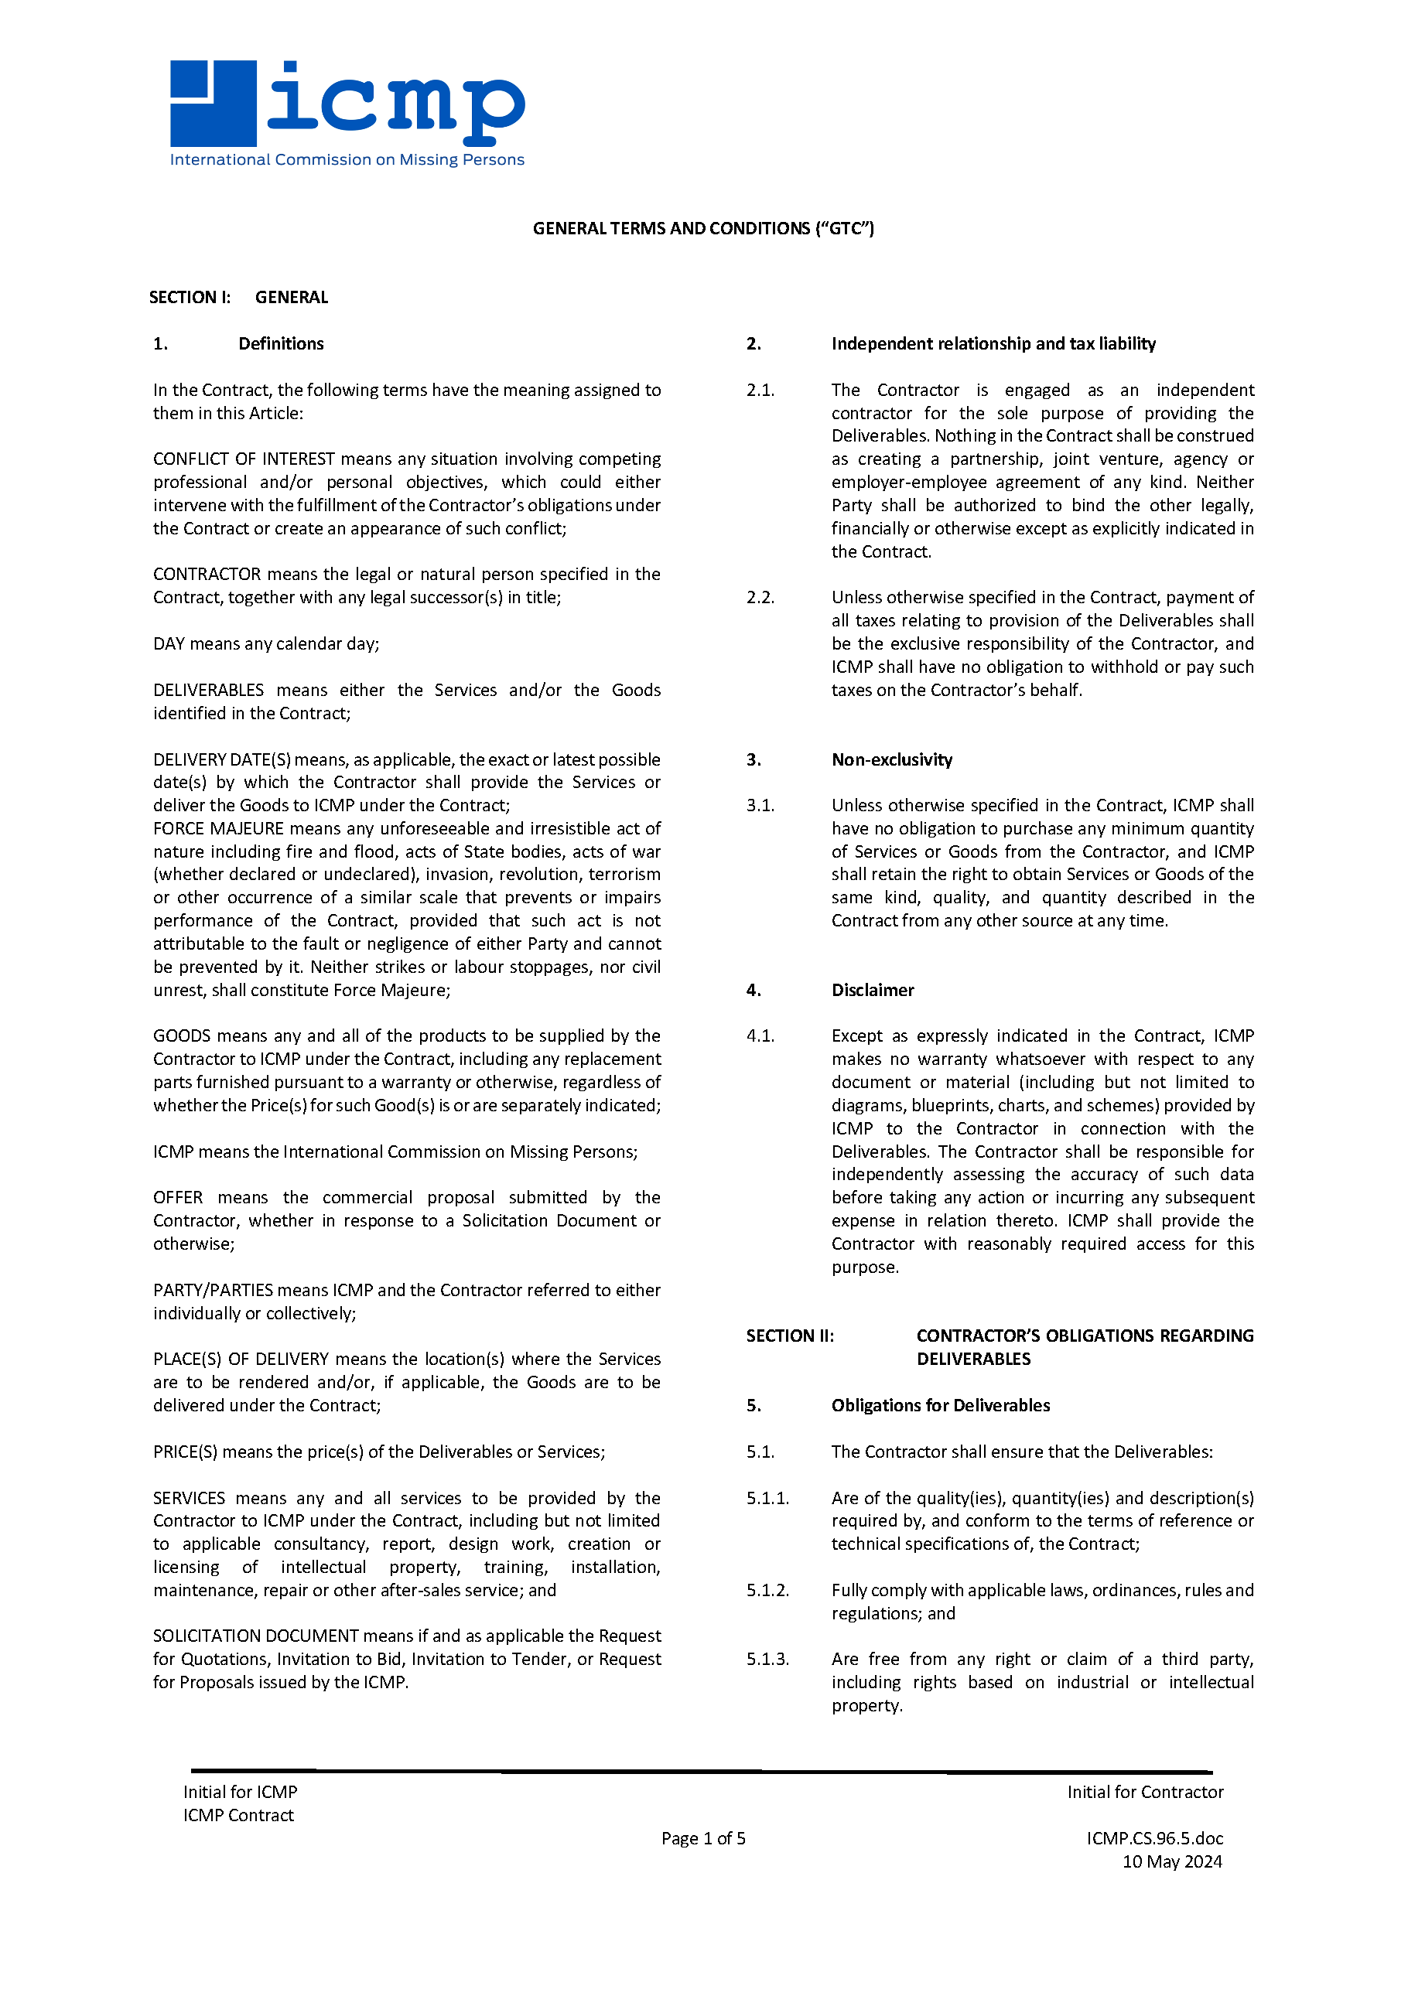

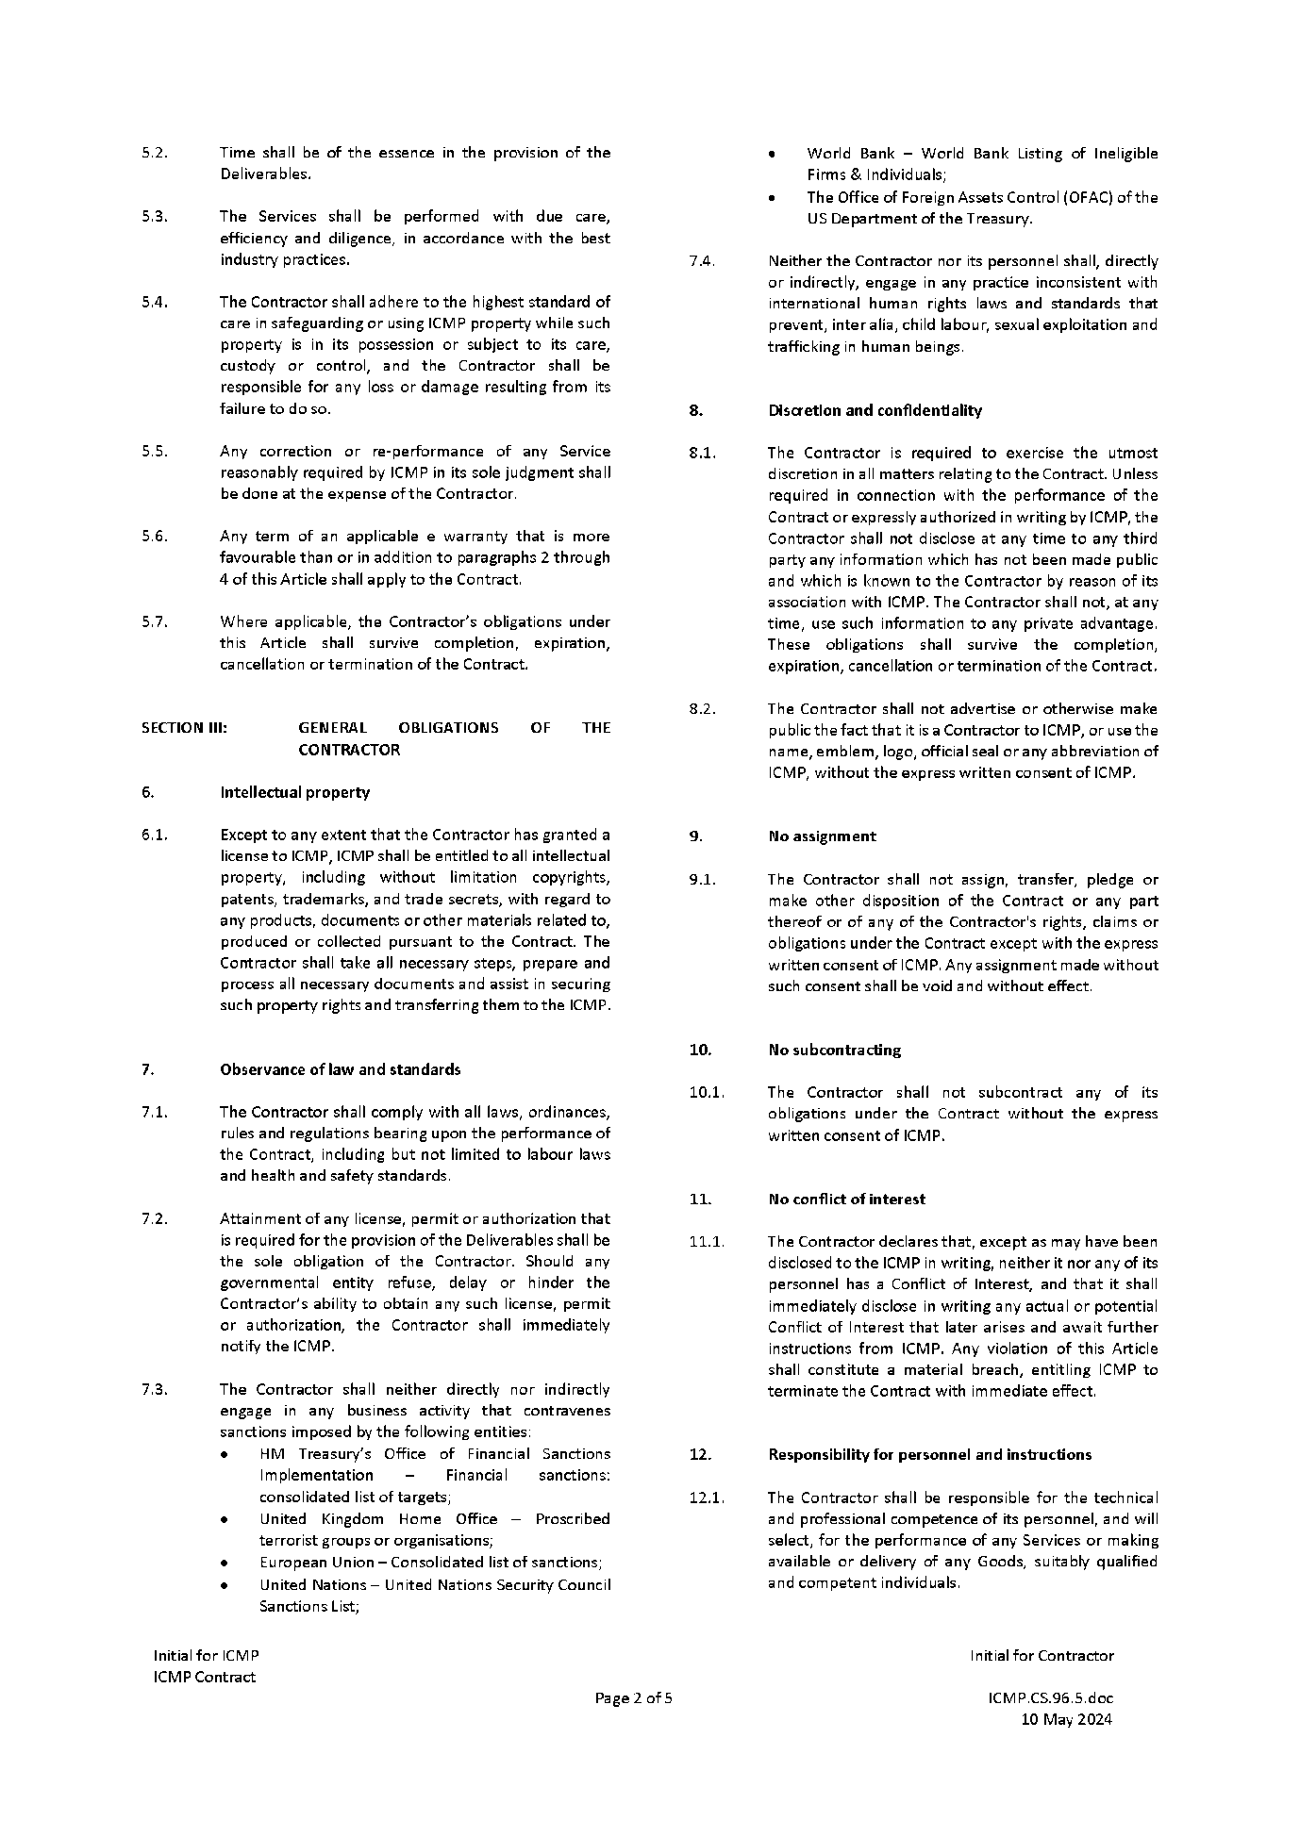

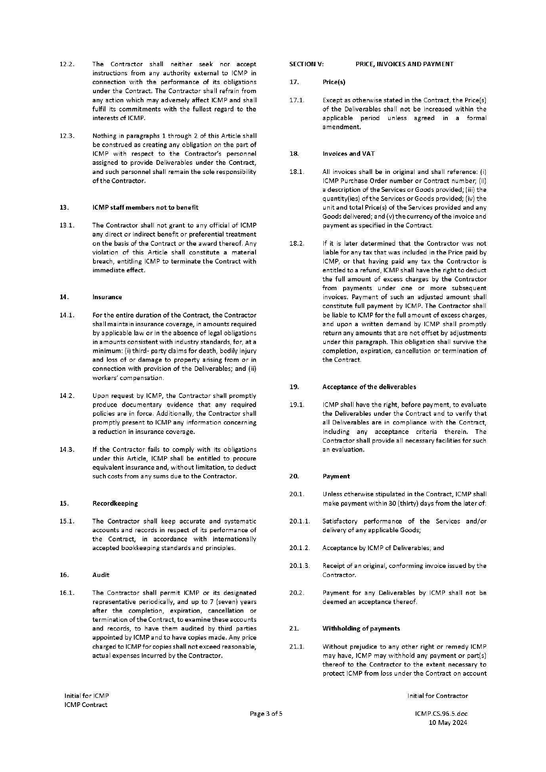

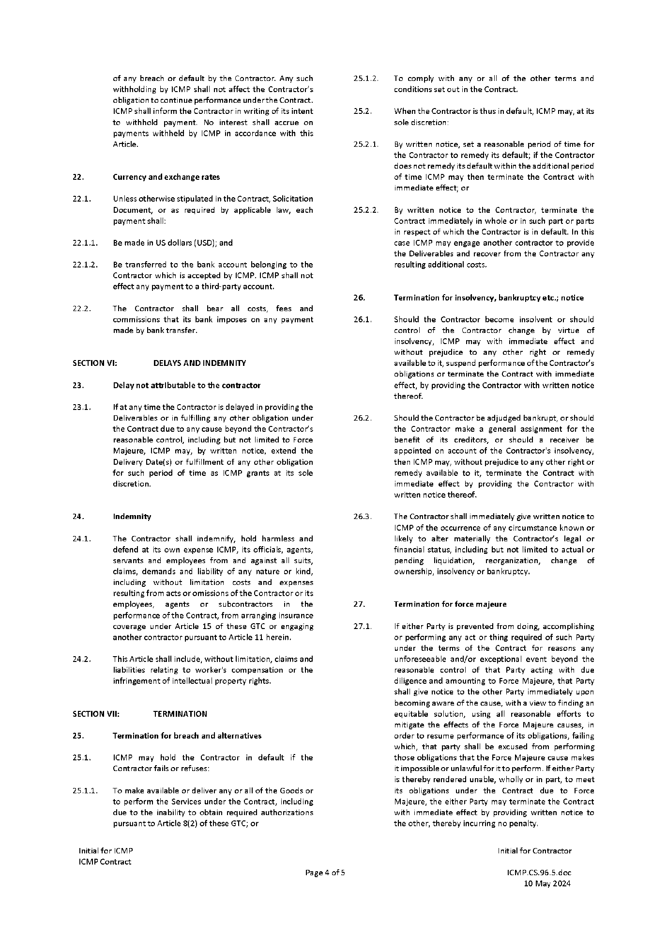

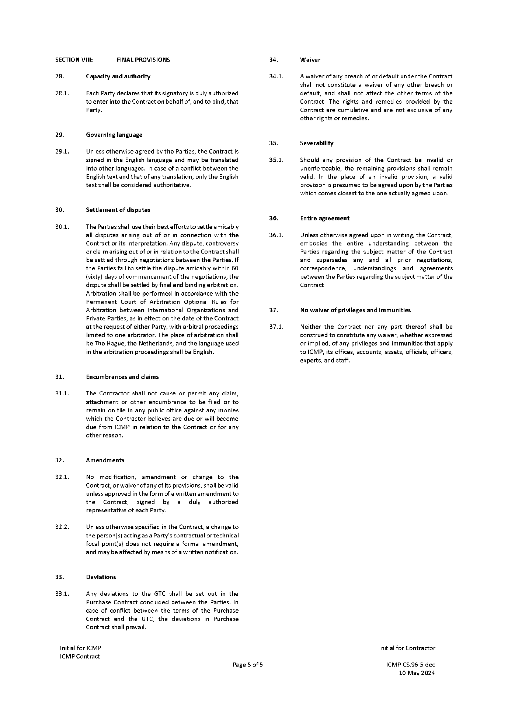

ANNEX II: FORM OF CONTRACT
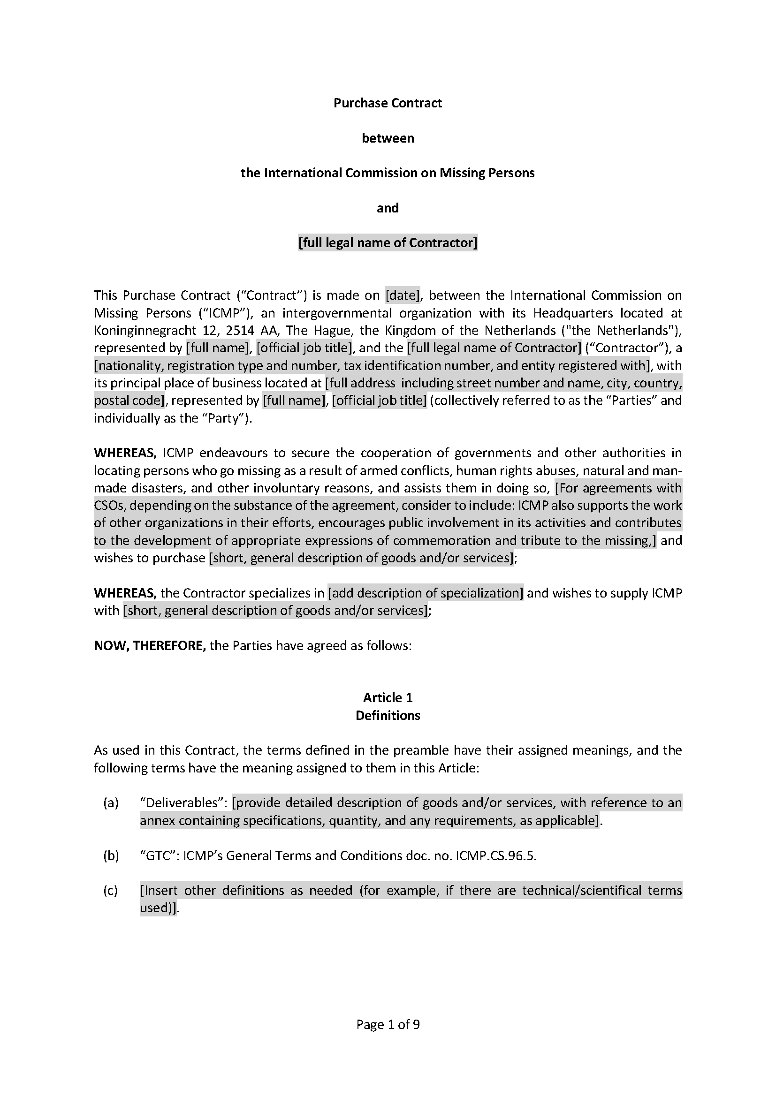

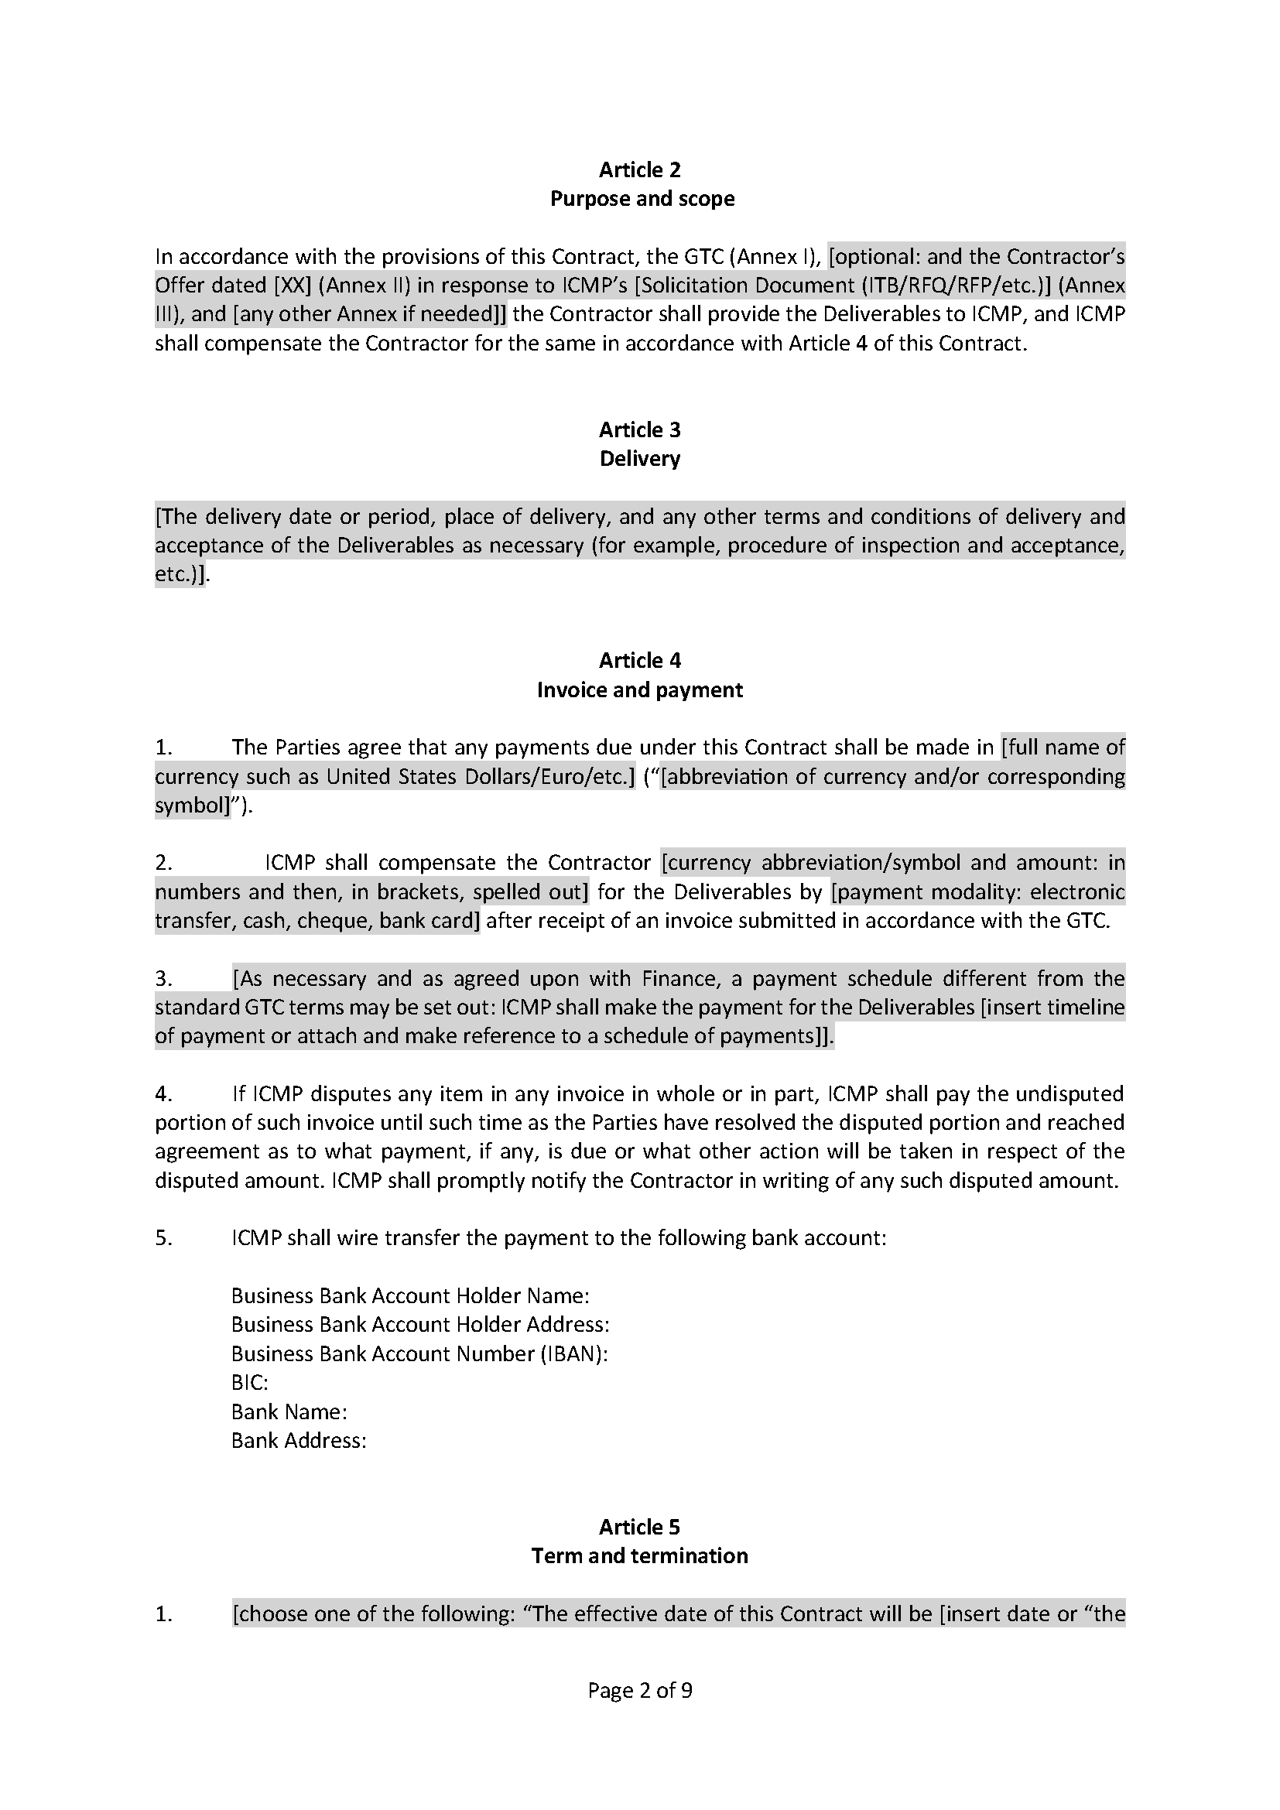

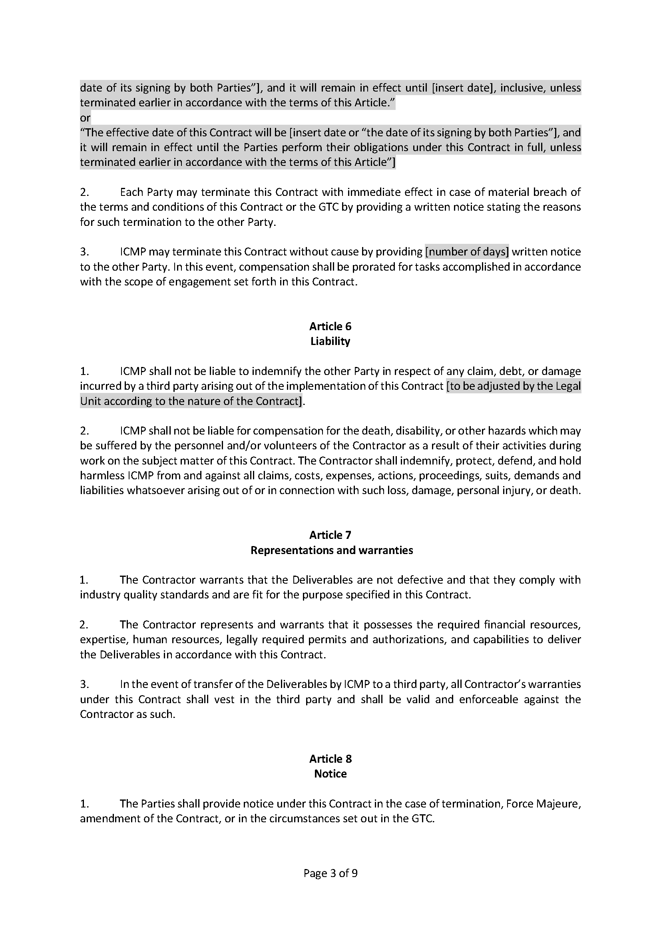

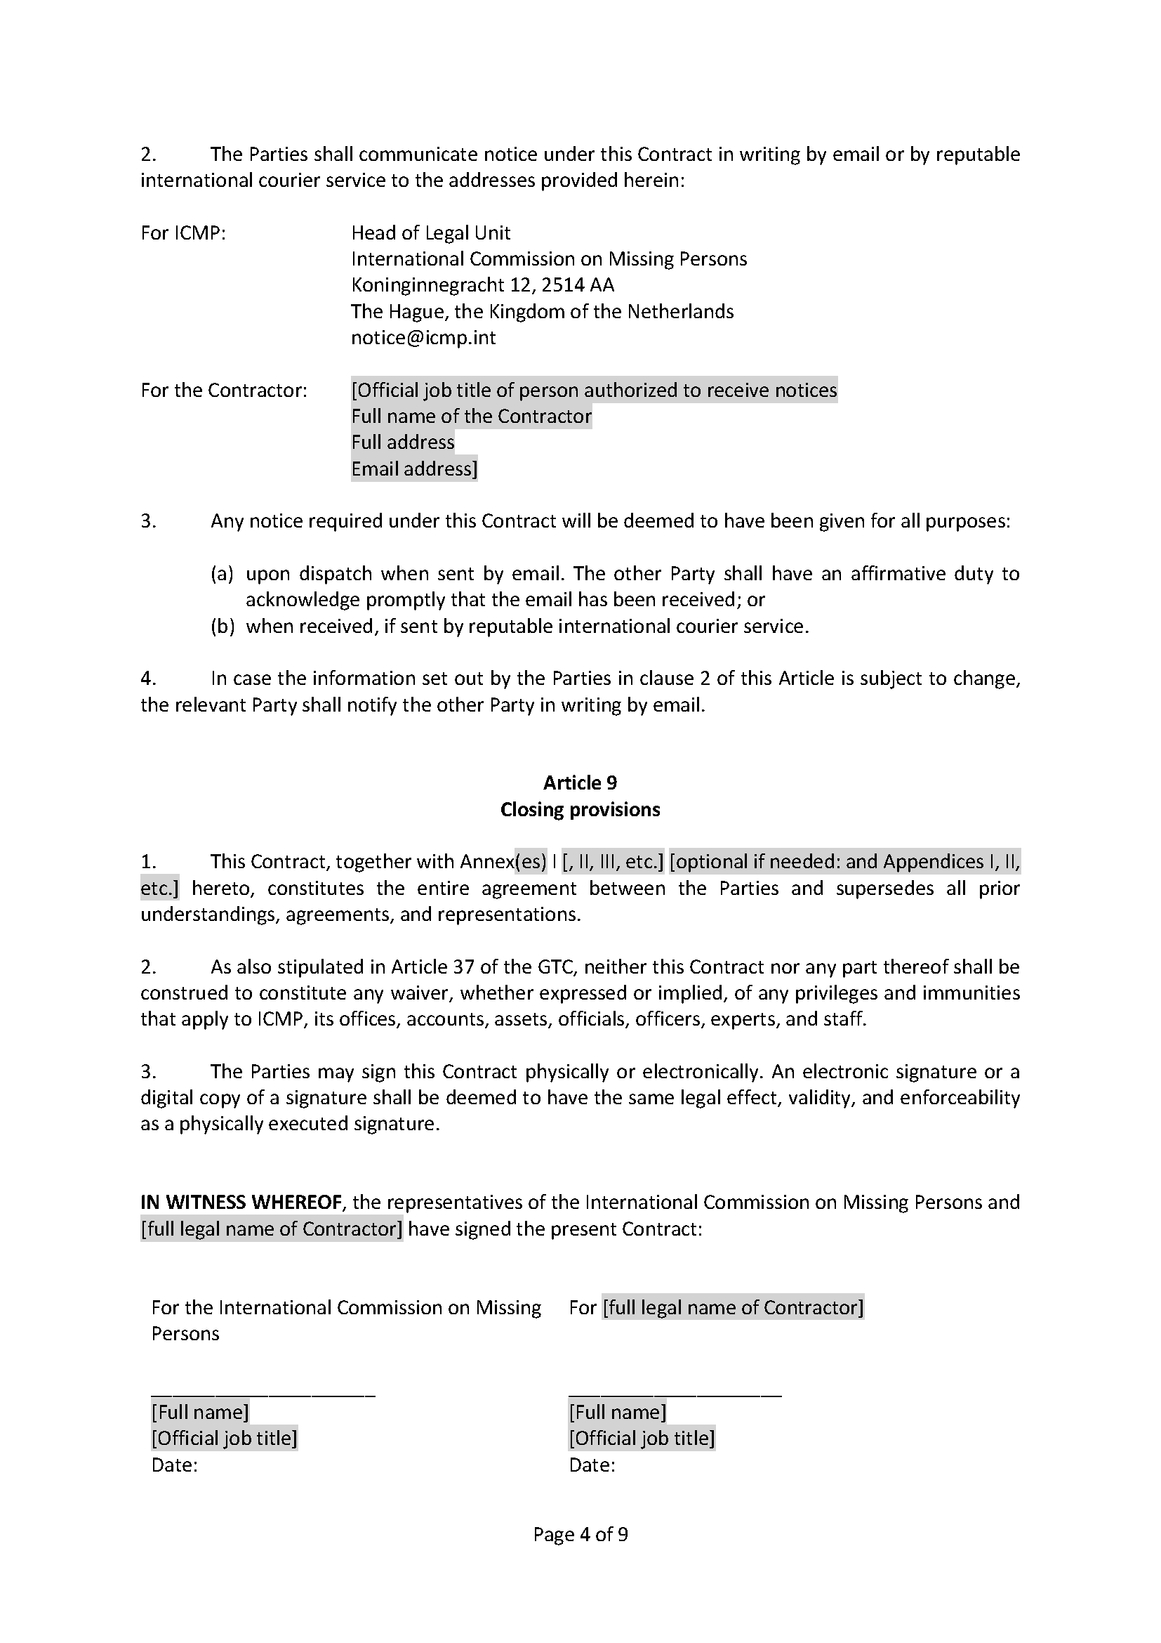

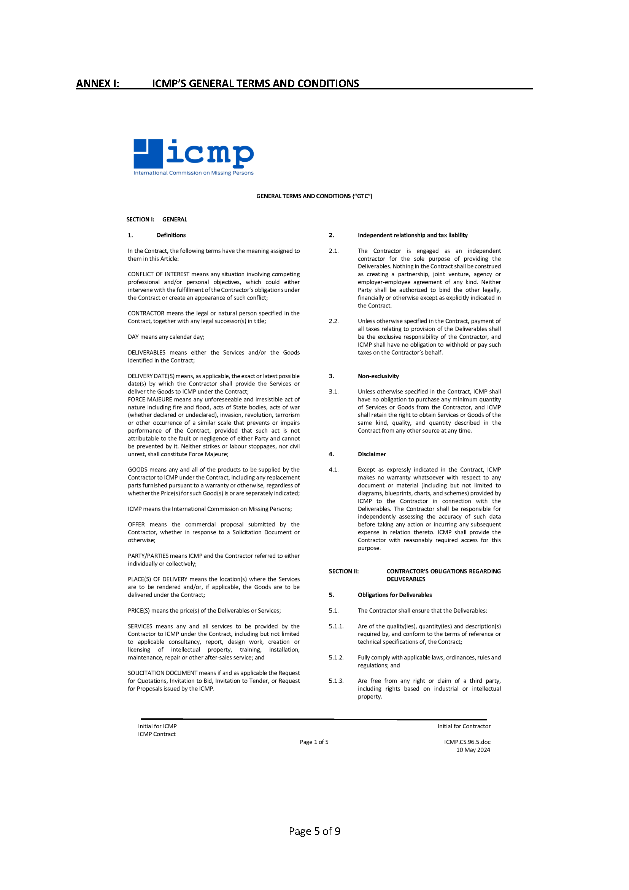

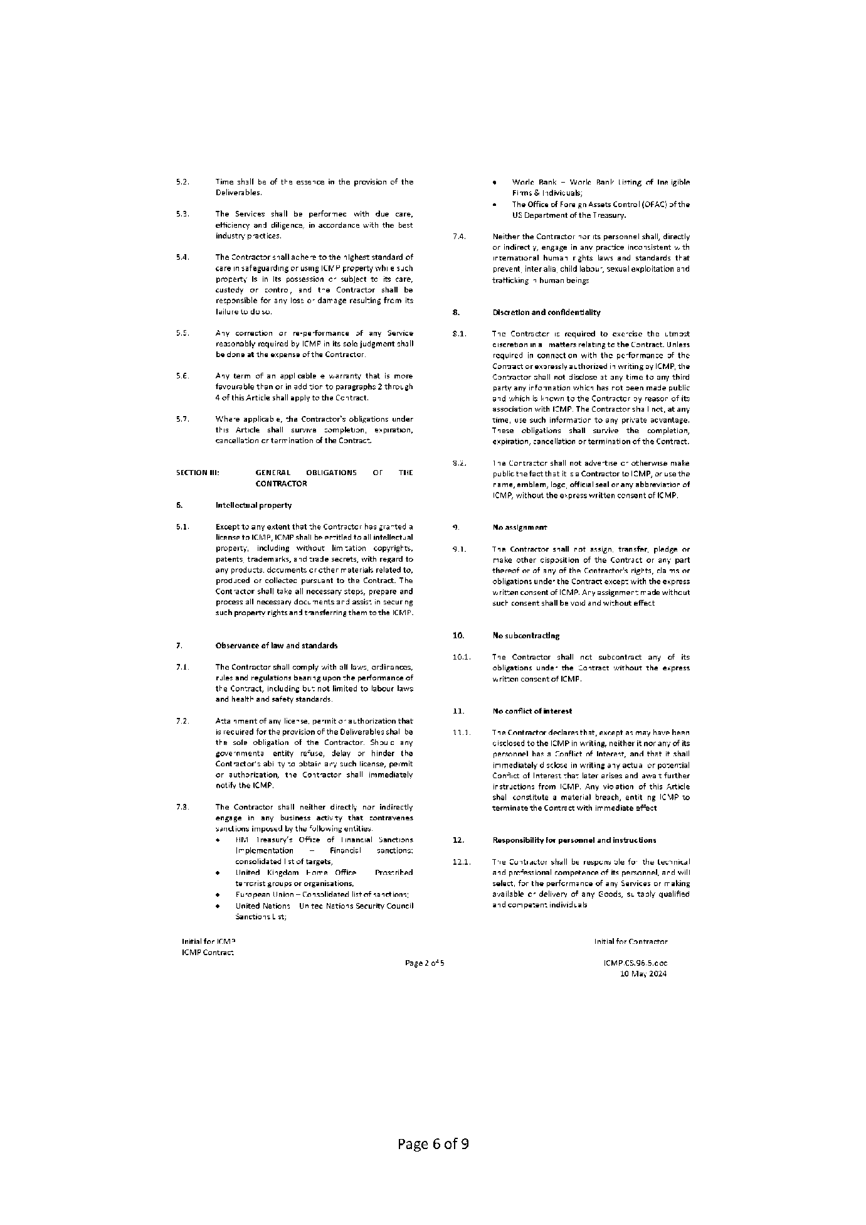

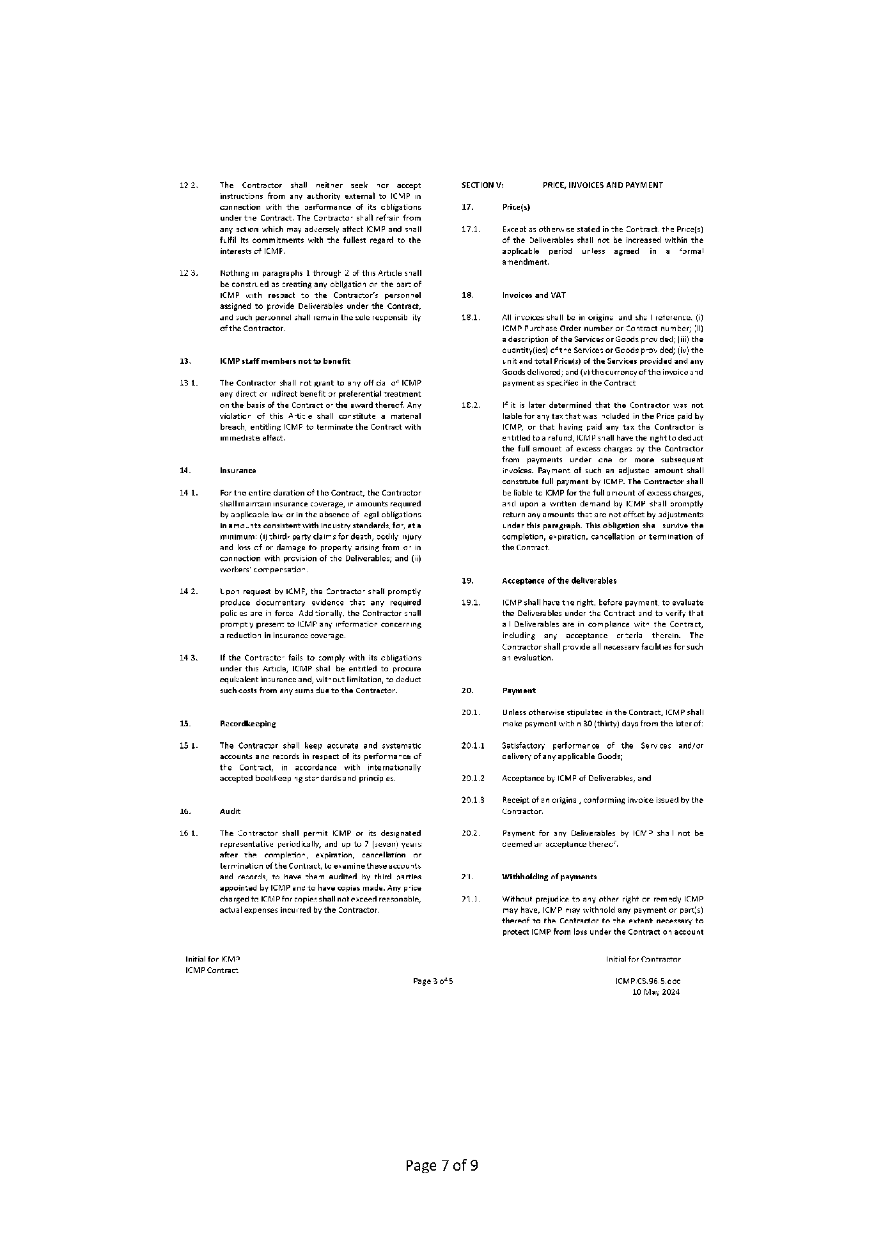

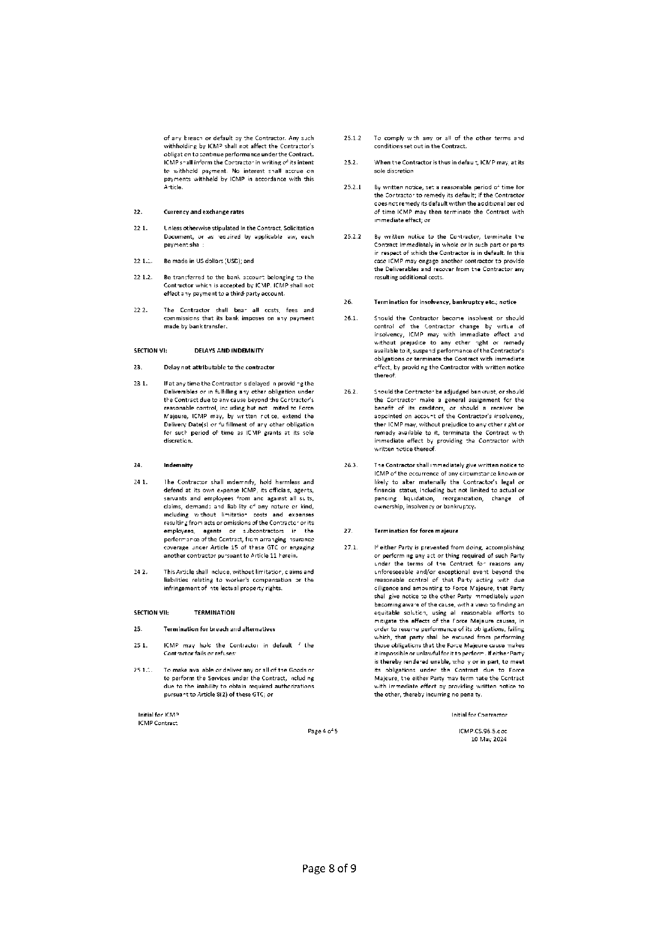

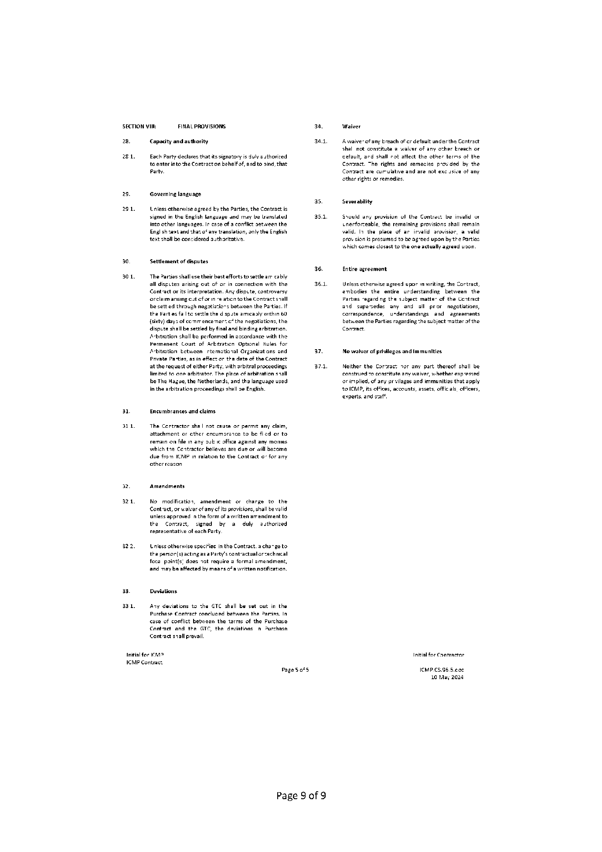

ANNEX I TO CONTRACT: MANUFACTURER’S AUTHORIZATION

Manufacturer’s Authorization Letter

[The Contractor shall require the Manufacturer to fill in this Form in accordance with the instructions indicated. This letter of authorization should be signed by a person with the proper authority to sign documents that are binding on the Manufacturer.]

Date: [insert date (as day, month and year) of Contract]
ITB No.: [insert number of Contract]

To: International Commission on Missing Persons (ICMP)

WHEREAS

We [insert complete name of Manufacturer], who are official manufacturers of [insert type of goods manufactured], having factories at [insert full address of Manufacturer’s factories], do hereby authorise [insert name of bidder] to negotiate and sign the Contract, the purpose of which is to supply the Goods under the Invitation to Bid referenced ITB/ICMP/HQ/010726 on our behalf [insert name and or brief description of the goods].

We further confirm that:
- the Goods offered by the Bidder are manufactured by us, are genuine, and new. In the event the Bidder is awarded the contract, we shall provide the necessary technical support and after-sales service as required.
- We extend our full guarantee for 36 months from the date of delivery that all kits comply fully with the specifications provided in the ITB/contract, and to replace those kits that are non-conforming to specifications due to manufacturing defects or poor storage during manufacturing or shipping and confirm that such kits will be replaced by the Contractor at no additional cost to the ICMP.

Signed: [insert signature(s) of authorised representative(s) of the Manufacturer]

Name: [insert complete name(s) of authorised representative(s) of the Manufacturer]

Title: [insert title]

Duly authorized to sign this Authorization on behalf of: [insert complete name of Manufacturer]

Dated on ____________ day of __________________, _______ [insert date of signing]

ANNEX II TO CONTRACT: CONTRACTOR’s OFFER (including Appendices I and II)

